**Table of Contents**

* [**1. Email Marketing**](https://shanebarker.com/blog/best-digital-marketing-strategies-for-startups/#1_Email_Marketing)
  + [**Here are some tips on creating a successful email marketing campaign:**](https://shanebarker.com/blog/best-digital-marketing-strategies-for-startups/#Here_are_some_tips_on_creating_a_successful_email_marketing_campaign)
* [**2. Social Media Marketing**](https://shanebarker.com/blog/best-digital-marketing-strategies-for-startups/#2_Social_Media_Marketing)
  + [**The following is a list of the benefits offered by social media marketing:**](https://shanebarker.com/blog/best-digital-marketing-strategies-for-startups/#The_following_is_a_list_of_the_benefits_offered_by_social_media_marketing)
  + [**How can you avoid these mistakes?**](https://shanebarker.com/blog/best-digital-marketing-strategies-for-startups/#How_can_you_avoid_these_mistakes)
* [**3. Pay-Per-Click Marketing (Google AdWords)**](https://shanebarker.com/blog/best-digital-marketing-strategies-for-startups/#3_Pay-Per-Click_Marketing_Google_AdWords)
  + [**Pay-per-click advertising offers many practical advantages, such as:**](https://shanebarker.com/blog/best-digital-marketing-strategies-for-startups/#Pay-per-click_advertising_offers_many_practical_advantages_such_as)
* [**4. Search Engine Optimization**](https://shanebarker.com/blog/best-digital-marketing-strategies-for-startups/#4_Search_Engine_Optimization)
* [**5. Influencer Marketing**](https://shanebarker.com/blog/best-digital-marketing-strategies-for-startups/#5_Influencer_Marketing)
  + [**Here are some reasons why startups should adopt influencer marketing:**](https://shanebarker.com/blog/best-digital-marketing-strategies-for-startups/#Here_are_some_reasons_why_startups_should_adopt_influencer_marketing)
* [**6. Content Marketing**](https://shanebarker.com/blog/best-digital-marketing-strategies-for-startups/#6_Content_Marketing)
  + [**By adopting content marketing strategies for your startup, you can:**](https://shanebarker.com/blog/best-digital-marketing-strategies-for-startups/#By_adopting_content_marketing_strategies_for_your_startup_you_can)
* [**7. Retargeting Ads**](https://shanebarker.com/blog/best-digital-marketing-strategies-for-startups/#7_Retargeting_Ads)
  + [**What is a retargeting ad, and how does it work?**](https://shanebarker.com/blog/best-digital-marketing-strategies-for-startups/#What_is_a_retargeting_ad_and_how_does_it_work)
* [**8. Viral Marketing**](https://shanebarker.com/blog/best-digital-marketing-strategies-for-startups/#8_Viral_Marketing)
* [**9. Affiliate Marketing**](https://shanebarker.com/blog/best-digital-marketing-strategies-for-startups/#9_Affiliate_Marketing)
* [**What is Affiliate Marketing?**](https://shanebarker.com/blog/best-digital-marketing-strategies-for-startups/#What_is_Affiliate_Marketing)
* [**Conclusion**](https://shanebarker.com/blog/best-digital-marketing-strategies-for-startups/#Conclusion)

**6 Types Of Digital Marketing Course Content**

**1- SEO Course**



Search Engine Optimization

To begin with, SEO or Search Engine Optimization is the process that ensures higher ranking of your website in the search engine.

In particular, SEO gets more traffic that is organic & relevant. This module of digital marketing training courses is crucial as it determines the rank of the website.

In addition, SEO can be thought of as increasing the visibility of your website so that it reaches the right audience.

Furthermore, when you end up ranking on top of search results, you can easily expect higher activities on your website, more brand visibility, brand awareness and conversions.

Moreover, SEO Marketing is an essential part of the Digital Marketing Course Content that will teach you SEO tactics and methods.

Lastly, with the knowledge SEO friendly domain, SEO friendly designs, link building, mobile SEO, off-page and on-page SEO, you can easily leverage your brand’s online presence

.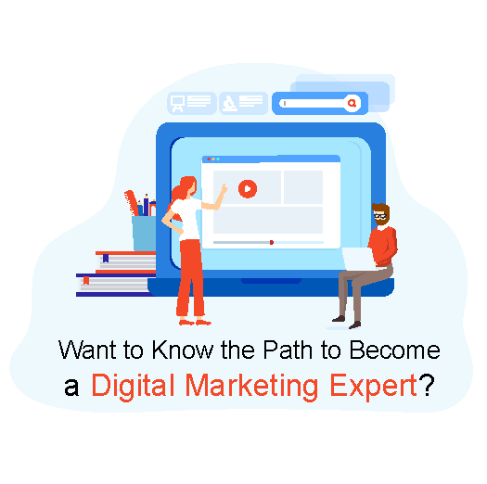

Bottom of Form

**However, some of the SEO techniques that you will learn from SEO marketing course are:**

**On-Page & Off-Page SEO Practices**

* Learn use of HTML, URL, Title, Meta Tags, H1, & Images
* Understand concepts of Crawling of XML & HTML Sitemaps
* Know Robots.txt, Achor text, & role of Linking
* Go through off-page SEO Tips & Tricks

**Learn SEO Via Best SEO Tools**

* Practice SEO with Google Search Console, Google Analytics setup and Bing Webmaster SEO Tools
* Understand the working of Keyword Planner tool and learn how to map keyword to Web pages
* Learn SEO Tools to do effective Competition Analysis

**Learn SEO Relevant Website Design Practices**

* Know how to make your website SEO friendly
* Understand Mobile responsive design & Importance of HTTPs
* Delve into specifications of Site schema & Technical Website Optimization
* Know the role of URL Architecture and do Page Speed Analysis
* Find out concepts related to Broken links, 301 redirects, Canonicalization, & Custom 404 Error pages

**Understand Best Link-Building Practices**

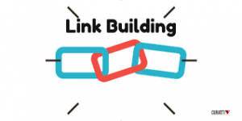

Link Building

* Learn what is Link building & Content marketing basics
* Know what Directory submissions, Local listings, and Niche backlinking are
* Understand Social bookmarking, Press Release, Blog & Article Optimization
* Find out SEO driven SoLoMo (Social, Local, Mobile) Strategies
* Uncover Social Media Backlinking, ORM & Influencer Outreach
* Delve into Local Seo & Mobile SEO practices

**SEO Site Audit & Algorithm Update**

* Learn On-page & Off-page SEO Audit Plans
* Delve into SEO audit tools like Screaming Frog, SEOprofiler, Moz, & domain tools
* Go through different Google SEO Algorithm Updates like Panda, Penguin, Hummingbird

**SEO Analytics**

* Understand SEO Tracking and Related Metrics
* Know how to Google Analytics Custom Reports & create your SEO dashboard

**2- Social Media Marketing Course**



Social Media Marketing

To begin with, Social Media Marketing is another important dimension of digital marketing training courses.

By the way, there was a time when social media platforms were only used to connect with friends and share one’s personal thoughts and feelings with the world.

However, with the increased use of Social Media, it has become one of the core components of digital marketing.

Consequently, as the big brands soon recognized the potential of Social Media. Subsequently, they quickly incorporated it into their promotional activities. This makes Social Media Marketing an integral part of a Digital Marketing Course Content.

Moreover, it is the youngest form of digital marketing, which helps brands to bring forth their image and message in a trendy way.

Usually, it is one of the most impactful forms of marketing, making it a necessary part of every marketing campaign.

When one opts for this Digital Marketing Course Content, he/she can learn how to research and know their audience, create high-quality relevant content, manage the business communication on different Social Media Platforms.

Generally, Social media marketing isn’t as easy as just scrolling down Facebook or Instagram and posting whatever one feels like. The social media course helps a business align its business plans with its Social Media Activities. Particularly, the Social Media Marketing Course includes-

**Know SMM History & Social Media Importance**

* Understand the evolution of Social Media Channels
* Go through relevant Social Media Stats and Trends (in India & Abroad)
* Understand Social Media Marketing via Social Media Success Stories
* Know key Idiosyncrasies of all Social Media Channels
* Learn how to choose relevant Social Channel for your Business
* Understand what is multi-channel Social Media Marketing

**Understand Community Building & Develop Facebook Marketing Strategies**

* Know what is community building on Facebook and how to create the right Facebook Brand Pages
* Go through EndgeRank Algorithm to understand how successful marketers engage their audiences on Fb
* Create Facebook Pages and Implement Facebook Marketing Strategies
* Understand Facebook Marketing to ensure an increase in followers, fans, and engagements
* Go through Important Facebook Insights and Success Stories
* Implement Facebook Marketing Strategies from Goals to Revenues
* Understand Competitive Research on Facebook

**Understand Facebook Ads**



Facebook Advertising

* Go through different types of Facebook Ads
* Do a Comparative analysis of Facebook Ads & Google AdWords
* Know the role of CTR in Facebook
* Understand how to create an Ad Copy in Facebook Advertising
* Optimize your Ad Copy and do result-oriented Targeting

**Understand Twitter Marketing & Types Of Twitter Ads**

* Understand the basics of Twitter Marketing
* Know what is Hashtag, how to create Twitter Trends
* Understand how to do Brand Building, PR, and Customer Engagement on Twitter
* Go through Twitter Marketing Tools
* Create a Twitter Marketing Strategy
* Know different kinds of Twitter Marketing Campaigns
* Learn what is Promoted Tweets, Promoted Accounts and Promoted Trends on Twitter
* Go through Different Types of Twitter Ads

**Understand LinkedIn Marketing In B2B Businesses**

* Understand LinkedIn basics and how to do lead generation on LinkedIn
* Know how to create LinkedIn Company Page, Groups, and Developer API
* Go through different LinkedIn Ads and understand how to run them to generate leads
* Delve into LinkedIn for HRs, Job-Seekers and Businesses Programs

**Learn YouTube Marketing**

* Delve into the basics of YouTube Marketing
* Understand the best YouTube Marketing Practices & Tools
* Know YouTube Ads and understand their dynamics
* Go through case studies of viral national and international YouTube Campaigns
* Learn key Idiosyncrasies of Successful Video Marketing

**Understand Pinterest, Instagram, Snapchat & Other Social Media Marketing**

* Learn Pinterest Marketing, Ads, and Best Practices
* Implement Pinterest for Business
* Understand Instagram Basics, Ads, Tools and Practices
* Delve into Snapchat Advertising
* Understand how to use Google+, SlideShare
* Know how Social Channels generate ROI for businesses

**Delve Into Social Media Marketing Analytics**

* Learn how to do Measurement on Social Media
* Go through the Framework for ROI Measurement
* Understand how to create an ROI Metrics Dashboard for SMM
* Find out different Social Media Marketing Tools to Measure ROI

**3- Email Marketing Course**



Email Marketing

Now, we have come down from the youngest to one of the oldest Online Marketing forms i.e. Email marketing.

To begin with, Email marketing though old is still one of the most effective ways for a business to connect with its audience. A deeper relationship and noise-free targeting are only possible through email marketing.

However, the goals of this Email Marketing course are to teach students how to drive new sign-ups, generating new leads, targeting an audience in a way that bears results and ultimately turning potential customers into customers.

Emails can give a business 6 times the click-through than tweets. In addition, Email Accounts Holders are 3 times more than Facebook or Instagram account holders are. Furthermore, these make email marketing an indispensable means of connecting to the audience.

Moreover, Email marketing is something that every business can take part in. Some of the major components of email marketing are Announcements, Marketing offer, Newsletter, and Event invitation.

Subsequently, the Email Marketing Course Content includes-

**Email Marketing Basics & Evolution**

* What is Email Marketing
* Email Marketing Case Studies
* How Email Marketing Works
* Components of Email Marketing

**Email Marketing – Mailing List & Organizing The Mailing List**

* What is the Mailing List?
* Types of Mailing List
* The formula for Growing Email List
* Strategies to Grow Email List
* Formatting Emails, Opt-in, and Opt-Out

**HTML & Text Emails**

* What is HTML Email
* Plain Text Email
* How to use HTML and Text Emails

**Newsletters Announcements & Event Invitation**

* How to use Newsletter in Email Marketing
* Role of Announcements Emails
* Importance of Event Invitation Emails
* Case studies of different types of Emails

**Content & Landing Pages**

* Email Copywriting
* How to Write Subject Lines?
* Making Email Content Relevant and adding a CTA in your email
* How to Send Personalized Emails
* Role of Landing Pages in Email Marketing
* The ideal landing pages case studies

**Email Marketing Spam Compliance & How To Avoid Spamming?**

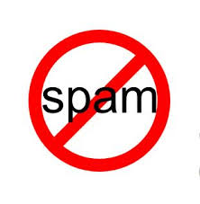

Avoid Spamming

* CAN Spamming
* How to Check Spam Compliance of your Emails
* Spam Testing
* Practices to avoid being spammed

**Avoid Being Blacklisted In Email Marketing**

* Single Opt-in Practices
* Double Opt-in Practices
* Role of opt-out, Subject line, Content, Sender’s address, etc.
* How to check if you are blacklisted

**Service Providers, Automation & Metrics**

* Comparison of Email Marketing Services Providers
* Role of Scheduling and automation in Email Marketing
* Tracking in Email Marketing
* Segmentation in Email Marketing
* Analytics in Email Marketing

**Follow UPS, Tools & Email Marketing – Tips**

* Role of Follow-Ups in Email Marketing
* Top Email Marketing Tools
* Best Email Marketing Tips

**4- Content Marketing Course**

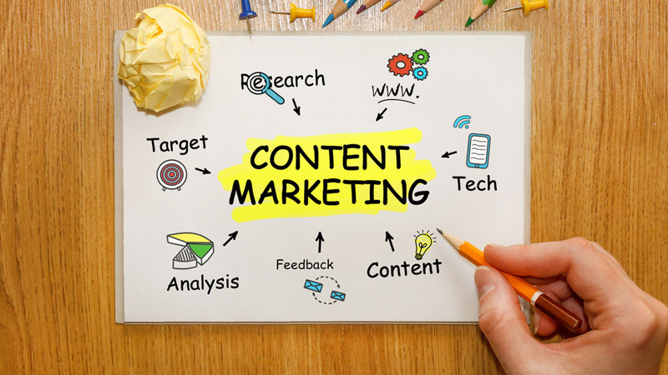

Content Marketing

Content Marketing is what makes everything possible in digital marketing practices.

When you have great content, it takes the pressure off the marketers to attract the audience. Furthermore, great content is another way to optimize your page for getting more visibility by the search engines.

All such features make it one of the most crucial parts of Digital Marketing Course Content.

When done right, content can attract the target audience and convert them into customers.

For achieving that, one has to design and publish high-quality content in the form of blogs, articles, images, videos etc. With Content Marketing Courses online, you can easily get hands-on experience of this.

Content Marketing Courses online are therefore designed in a manner that teaches its students on how to target their audience. It solves content-related problems, decides on the USP of the content marketing activities.

You can also choose a content type from various content marketing formats.

Furthermore, for an effective content marketing campaign, one has to know what type of content should be published on different online platforms.

Again, how to curate high-quality content and use content management systems, are all the subjects, which are a part of the content marketing course & which finds their place in this section of Digital Marketing Course Content.



Bottom of Form

By the way, different modules of Content Marketing Online Course include-

**Content Marketing Online Course Overview**

* History of Content Marketing
* Content Marketing Basics and overview
* Know your Content Marketing Goals and Prerequisites
* How Content benefits Business multifold Revenues
* Content Marketing Careers

**Content Marketing Online Course – Content Creation & Targeting Customers**

* Define your Content Creation Goals
* Know your customers and collect information about them
* Create Personas for your Customers
* Know tools to help Content Creation, Editorial Calendars, Ideation and research, Format
* Understand the different types of Content- Blogs, Lifecycle Emails, E-Newsletters, Brochures, Whitepapers, E-Books, Digital Magazine

**Content Marketing Online Course – Know What Blogging Is**



Blogging

* What is Blog
* How Blogging Works
* What are the benefits of Maintaining a Blog
* Understand the interrelation between Blogging & SEO
* Know how to make money via Blogging

**Content Marketing Courses Online – Make Your Content Strategy**

* Know the difference between Content Marketing & Content Strategy
* Define Audience for your Content Strategy
* Understand how to do Content Audit
* Know how to Organize and Tag Your Content
* What is the Success Metrics you should include in Content
* How to align your Content Style with Brand’s Personality
* Know how to Document your Content Strategy

**Content Marketing Courses Online – Content Promotion, Analysis, & Reporting**

* How to Build an Audience
* Learn Influencer, Email and Comment Marketing
* What is Guest Posting
* Use of PR, Social Media, and Paid Promotion
* Know the Core Metrics to Analyze Content Strategy
* Delve into Pageviews, Bounce Rate, Engagement metrics, Social metrics

**5- Search Engine Marketing Course**



Search Engine Marketing

Search Engine Marketing is the primary form of Digital Marketing Advertising methods.

It is one of the most highly used digital marketing practices in today’s competitive environment and one of the most effective ways of grabbing eyeballs to grow one’s business and promote products.

Search Engine Marketing can involve both paid and unpaid methods. It is mainly the practice of increasing the visibility of a website and its products in the search engine result pages (SERPs) through the means of paid advertisements.

Here the advertisers have to bid against certain keywords that their target customers are often found entering in the search bars. The advertisements that appear on the search engines like Google, Yahoo and Bing are called Pay per Click ads. These ads come in various formats. Some can be product listings while some are simple text-based ads.

If you are wondering what is the basic difference between SEM and SEO then let us enlighten you that SEM is mainly paid to get traffic whereas SEO is unpaid and organic. Further, SEM is highly based on bidding and the use of certain keywords.

Moreover, PPC, which is the major form of SEM, can be thought of as buying relevant traffic from paid search engine ads.

In short, SEM Course Content includes-

**PPC Introduction**

* Evolution and History of PPC
* Search Engine Advertising and PPC Ads
* The workflow of PPC Ads and General Formula for calculating PPC
* Properties of a Compelling PPC Ad and Advantages of PPC

**Understand The Complete PPC Glossary**

* Ad Group
* Call-To-Action (CTA)
* Ad Position
* Campaign
* Ad Network
* Click-Through-Rate (CTR)
* Conversion
* Ad Rank
* Conversion Rate
* Cost Per Action or Cost Per Acquisition (CPA)
* Destination URL
* Display URL
* Cost Per Click (CPC)
* Geo-targeting
* Cost Per Mille (CPM)
* Impression
* Keyword
* Landing Page
* Negative Keywords
* PPC Bid
* Prospect
* Quality Score
* Search Engine Result Page (SERP)
* Split Testing

**Ads On Google**

* Know how to create Google AdWords Account
* Go through steps involved in creating a PPC Campaign in Google AdWords

**Keyword List In PPC**

* Categorizing the Keywords
* User Phrases
* Product-Complementary Phrases
* Competitor Phrases
* Keyword Match Types
* Product Phrases
* Building a Keyword List
* Brand Phrases
* Keyword Research Tools
* Negative Keywords

**Parts Of PPC Ad**

* Steps involved in Creating a PPC Ad
* How to do Market and Audience Research, Keyword Research
* Understand how to build Pay-Per-Click Ad, PPC Landing Pages
* Know how to Track, Measure, and Report in PPC
* How to Optimize the Ad
* Know the Elements of a PPC Ad
* How to create a PPC Ad Using Google AdWords

**PPC Landing Pages**

* Know the role of PPC Landing Pages
* Go through Types of Landing Pages
* Know the Elements of an Effective Landing Page
* Features of Creating a Well-Formatted and Informative Landing Page
* Know how to test the landing page

**Bidding In PPC**



Bidding in PPC

* Know what is PPC Bidding
* Go through the Factors that Affect Bidding
* Know What to Bid For and how much to Bid
* Go through best Bid Management Solutions
* Know how to make PPC Pricing Strategies

**Yahoo & Bing Search Marketing**

* Know how Microsoft Ad Center manages Yahoo and Bing Advertising
* Creating an Ad and Bidding in Microsoft Ad Center
* Know the Structure of an Ad Account in Yahoo and Bing Advertising
* How Yahoo/Bing Ads Editor Works
* Go through the steps involved in Budget and Billing

**Measuring Results**

* Learn all the important Metrics in PPC
* Go through %Served, Average Cost per Click (CPC), and Average Position
* Understand Bounce Rate, Clicks, Click-Through-Rate (CTR), Conversions and Impression Share
* Delve into Impressions, Quality Score, and ROI

**6- Web Analytics Course**



Web Analytics

Lastly, we have the Web Analytics Course helps you Track and Monitor Online Campaigns

In the first place, Analytics Training gives you insights into the performance of your Site, Data Flow, and Visitors’ behavioural preferences.

Here, you will get to learn different analytics tool that you can use to collect, track, measure, analyze and report your website data.

Hence, Web Analytics Digital Marketing Course Content will help you analyze the performance of your website that will guide you to optimize your web page in the most result-oriented manner possible.

Furthermore, once you master Analytics, you can understand your traffic source, analyze their behavioural tendencies, and improve your campaign to make it more result-driven.

With effective use of Analytics, you can track and measure ROI of marketing and advertising campaigns that will translate into more leads, better sales conversion and boosted online presence.

Generally, the Web Analytics Course includes-

**Analytics Introduction**

* History and Evolution of Web Analytics
* Learn how Google Analytics works
* Understand effective Audience Analysis and Acquisition Analysis
* Know the role of Behaviour Analysis and Conversion Analysis in Google Analytics

**Web Analytics Dashboard**

* SEO dashboard
* Content dashboard
* Website performance dashboard
* Real-time overview dashboard
* E-commerce dashboard
* Social Media Dashboard
* PPC dashboard
* Metrics of Each Dashboard

**Google Analytics**

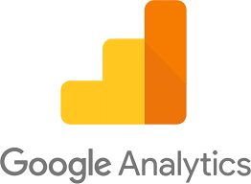

Google Analytics

* Go through the Basic Metrics and Main Sections of Google Analytics reports
* Delve into traffic sources, Direct, Referring, and Search traffic
* Find out how to integrate Google Analytics with AdWords and AdSense
* Understand Benchmarking, Bounce Rate, Click, and Conversion
* Examine Direct Traffic, Filter, Funnels, Goal and Goal Conversion Rate
* Learn the role of Impression, Keywords, Landing Page, and New Visitor
* Understand Organic Traffic, Paid Traffic, Page View, and Returning Visitor
* Know the role of Time on Site, Tracking Code, Traffic and Traffic Sources

**Analytics Tools**

* Understand the working of Optimizely
* Know how Kissmetrics Works
* Understand how Crazy Egg Functions

**Key Metrics In Google Analytics**

* Know what to measure in Google Analytics
* Go through Pageviews, Bounce Rate, and Pages per session
* Know Demographic info, Organic traffic, Social traffic, Referral traffic
* Understand the role of Direct traffic, Source/Medium, and Landing Pages

**Segmentation In Google Analytics**

* Know what is Data Segmentation
* Understand how to do analysis using Segmentation

**Web Analytics Conversions**

* Know what is Conversion in analytics
* Go through different types of goals
* Destination Goal, Duration Goal, Event Goals, and Pages/Session Goal
* Know the role of funnels in Google Analytics
* Understand how Multi-Channel Funnel Works

**Other Kinds Of Analytics**

* Role of Social Media Analytics
* Importance of E-commerce Analytics
* Role of Mobile Analytics